**The Library & E-Book Rental Portal CRM**

**ProjectOverview**  
The Library & E-Book Rental Portal CRM is designed to centralize and automate the management of physical book lending and digital e-book rentals within a single, user-friendly platform. It streamlines core operations such as member registration, catalog management, inventory tracking, and rental scheduling. Key features include real-time availability updates, automated reminders for due dates, secure online payments, and insightful analytics dashboards for usage trends and customer preferences. By integrating these capabilities, the CRM addresses the business need to reduce manual administrative work, improve accuracy in tracking rentals, and enhance the overall user experience for both staff and customers.

**Objectives**  
The primary goal of building this CRM is to enable efficient customer and inventory management while offering a seamless borrowing and rental experience. Specific objectives include: automating routine tasks such as renewals and late-fee calculations, providing staff with actionable insights through reports, and giving customers easy self-service options for browsing, reserving, and renting books or e-books. Achieving these objectives delivers clear business value—better customer satisfaction and retention, streamlined operations that lower administrative costs, and data-driven decision-making to expand popular collections and improve profitability.

**Phase 1: Problem Understanding & Industry Analysis**

**1. Requirement Gathering**

* **Functional Needs:** User registration/login, catalog search and filter, physical book checkout and return, e-book rental and download, payment integration for rentals/late fees, automated reminders/notifications, admin dashboard for analytics and reports.
* **Non-Functional Needs:**Secure data handling, high availability, mobile responsiveness, scalability for growing collections and user base, and seamless integration with third-party payment gateways.
* **Data Requirements:** Member profiles, book/e-book metadata, transaction history, rental/return dates, and usage analytics.

**2. Stakeholder Analysis**

* **Primary Stakeholders:**
  + **Library Members/Customers** – need a convenient way to browse, reserve, and rent books/e-books.
  + **Librarians/Staff** – require tools to manage inventory, track rentals, and process payments efficiently.
* **Secondary Stakeholders:**
  + **Management/Owners** – need insights into trends, revenue, and inventory performance.
  + **Technology/IT Team** – responsible for implementation, integration, and maintenance.
  + **Publishers/Partners** – may provide e-book licenses and require usage statistics.

**3.Business Process Mapping**  
Typical process flow:

* **Member Onboarding:** Registration → Verification → Profile creation.
* **Search & Reservation:** Browse catalog → Check availability → Reserve book/e-book.
* **Issue/Rent:** System updates inventory → Sends confirmation and due-date notification.
* **Return/Auto-Expire:** Physical book returned and scanned; e-book access auto-expires → Late fees calculated if applicable.
* **Reporting & Analytics:** Dashboard provides real-time insights into rentals, revenue, and popular titles.

**4. Industry-Specific Use Case Analysis**

* **Traditional Libraries:** Digital transformation to reduce manual records and improve circulation tracking.
* **E-Book Market Growth:** Rising demand for instant digital rentals and flexible subscription models.
* **Education Sector:** Colleges and schools moving toward blended physical/digital libraries.
* **Competitive Edge:** Integrating both physical and digital services differentiates the portal from single-format competitors.

**5. AppExchange Exploration (Salesforce Context)**

* **Relevant Solutions:** Investigate Salesforce AppExchange apps like library management add-ons, e-commerce/payment connectors, and analytics packages.
* **Integration Opportunities:** Prebuilt components for inventory management, customer self-service portals, and marketing automation can reduce development time.
* **Evaluation Criteria:** Scalability, cost, support, and ease of customization to fit library-specific workflows.

**Phase 2 – Org Setup & Configuration**

**1. Company Profile Setup**

**UseCase**  
Establish organizational identity and global defaults so that rental due dates, revenue reports, and scheduled reminders follow the library’s local standards.  
*Configuration Steps*

1. Setup ▸ Company Information → **Edit**
2. Name: *City Central Library & E-Book Rental Portal*
3. Primary Contact: Library admin email
4. Default Locale: *English (India)*
5. Default Currency: *INR*
6. Time Zone: *Asia/Kolkata*

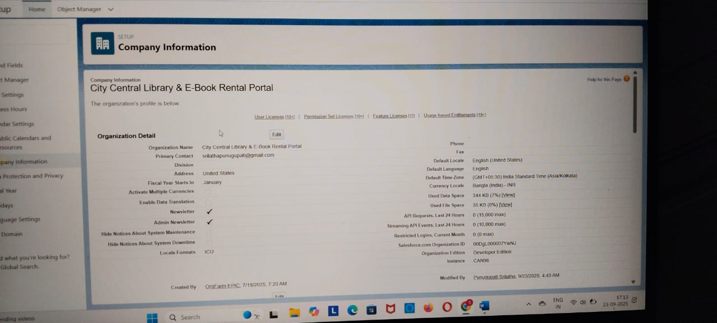

**2.Create Business Hours**

**Path:** Setup → Quick Find → **Business Hours** → **New**.

1. Go to **Setup** (gear icon → Setup).
2. In Quick Find type **Business Hours** and click it.
3. Click **New**.
4. Fill fields:
   * **Business Hours Name:** Library Standard Hours (or Main Branch Hours)
   * **Time Zone:** Asia/Kolkata (important — matches your org/company time zone)
   * For each day check if the library operates that day and enter **Start Time / End Time**.
5. **Save**.

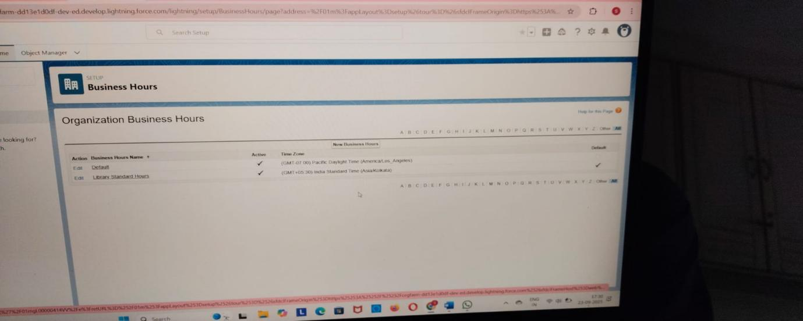

**Phase 3: Data Modeling & Relationships**

**● Standard & Custom Objects**

**1. Standard Objects**

| **Object** | **Purpose in Library Portal** | **Key Fields / Notes** |
| --- | --- | --- |
| Contact | Stores library member details | Name, Email, Phone, Membership Type |
| User | Stores internal users like Librarians, Admins, Support Staff | Name, Role, Profile, Login Access |
| Account | Optional: Could be used for corporate members or institutions | Name, Account Type |
| Product2 | Optional: Can store books/e-books if you choose product catalog | Name (Book Title), Product Code (ISBN), Description |

**2. Custom Objects**

| **Custom Object** | **Purpose** | **Key Fields** |
| --- | --- | --- |
| Book__c | Stores details of physical books | Title, Author, ISBN, Genre, Shelf Location, Number of Copies |
| EBook__c | Stores details of e-books | Title, Author, ISBN, Genre, Download Link, License Info |
| Rental__c | Tracks book/e-book rentals by members | Rental Number, Book (lookup), Member (lookup), Start Date, Due Date, Return Date, Late Fee, Status |
| Author__c | Stores author information | Name, Biography |
| BookAuthor__c | Junction object for many-to-many relationship between Book__c/EBook__c and Author__c | Master-Detail to Book__c/EBook__c & Author__c |
| Entitlement | Supports milestone processes like overdue reminders | Name, Entitlement Process, Start Date, End Date |

**● Record Types**

**1. Book__c Record Types**

* Physical Book – Represents all physical books in the library; includes fields like Shelf Location and Number of Copies for tracking.
* E-Book – Represents digital books; includes fields like Download Link and License Info for online access.

**2. Rental__c Record Types**

* Standard Rental – Default rental type for regular members with standard loan periods and fees.
* Premium Rental – Special rental type for premium members; may have shorter loan periods, higher late fees, or priority processing.

**3. Member__c / Contact Record Types**

* Student – For student members; may have lower borrowing limits and special discounts.
* Adult – Standard member type for general users; normal borrowing limits and fees.
* Senior – For senior citizens; may have extended loan periods or reduced late fees.

**● Page Layouts**

**Rental__c**

**Purpose: Capture all rental details and track overdue books.  
Sections and Fields:**

* Rental Info: Rental Number, Book/E-Book (lookup), Start Date, Due Date, Return Date, Status
* Borrower Info: Member (lookup), Contact Info
* Fees: Late Fee, Payment Status, Notes
* Related Lists: Milestones, Milestone History, Book or Member related records  
  Why: Organizes all rental data for easy tracking and automation (overdue reminders).

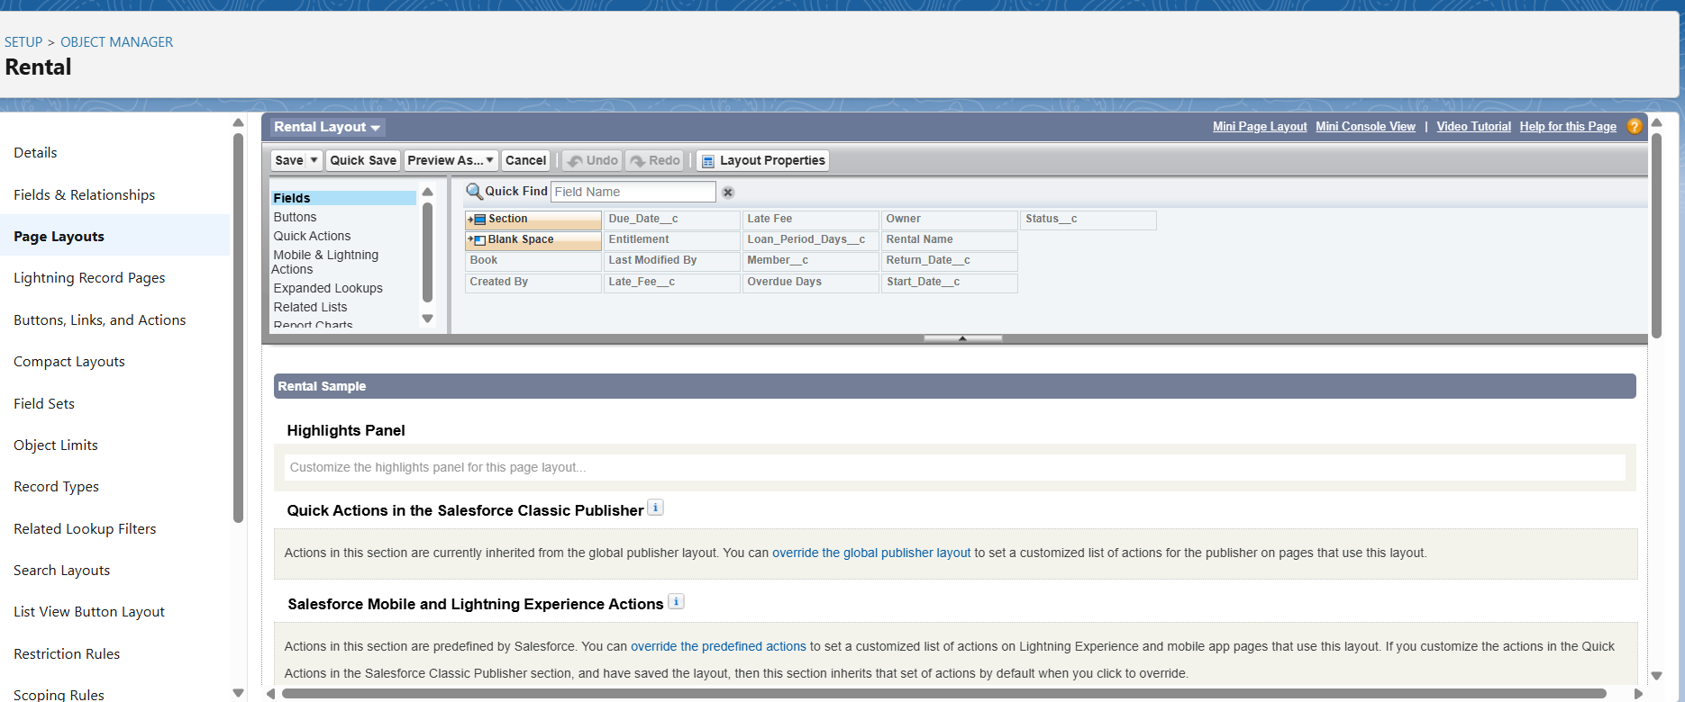

**● Compact Layouts**

**Purpose: Highlight key fields at the top of the record or in mobile view.**

* Rental__c: Book/E-Book, Member, Due Date, Status
* Book__c: Title, Author, Book Type
* **Schema Builder:**

Schema Builder = visual map of all objects and relationships in Salesforce.

Purpose in Library Portal:

* Plan your data model
* Validate relationships (Book ↔ Rental ↔ Member ↔ Entitlement)
* Create or edit objects/fields visually
* Include in report as a diagram of the Library CRM structure

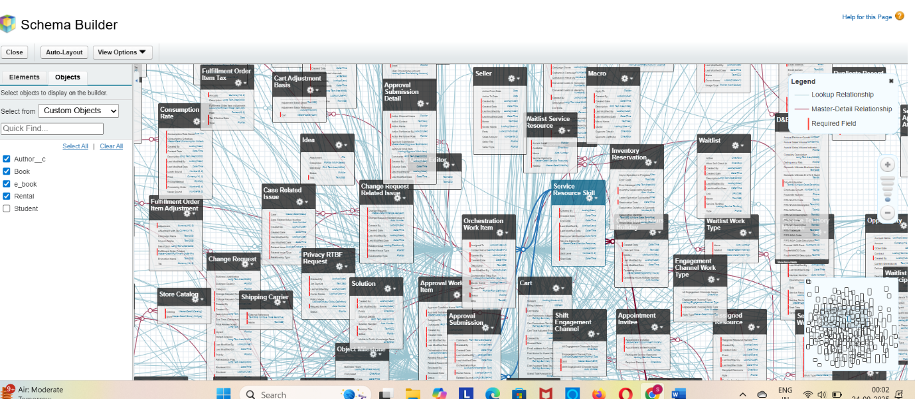

**Phase 4: Process Automation**

**● Validation Rules**

**A. Prevent Due Date Before Start Date**

Purpose: Ensures that the due date cannot be earlier than when the rental starts**.**

**B. Prevent Due Date in the Past**

Purpose: Prevents creating a rental with a due date that has already passed.

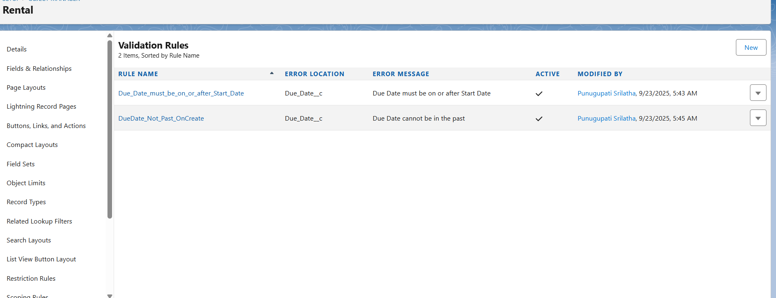

**Workflow Rules**

| **Workflow Rule Name** | **Object** | **Workflow Actions** | **Purpose** |
| --- | --- | --- | --- |
| Overdue_Rental_Alert | Rental__c | - Email Alert: send overdue email to member- Field Update: change Status__c to "Overdue" | Automatically notifies members and staff about overdue rentals. |
| Update_Returned_Status | Rental__c | Field Update: change Status__c to "Returned" | Automatically marks a rental as returned when the return date is entered. |
| Calculate_Late_Fee (Optional) | Rental__c | Field Update: update Late_Fee__c using formula: Overdue_Days__c * Daily_Late_Fee__c | Automatically calculates the late fee for overdue rentals without manual calculation. |

**● Process Builder**

Process Builder automates complex library workflows, combining multiple actions in one process.

In this project, it ensures members and librarians are notified, late fees are calculated, and statuses are updated automatically.